Geographic information of Cape town, South Africa for investing decision

Chokchai Kla-aim

JUNE 1, 2020

Abstract

Cape town is a capital of South Africa with the largest GDP in the continent. With 155 Billion USD GDP [2019], Cape town is marked as a target of investment from businesses around the globe in every sectors. In this research, Tourism industry was focused. The data analytics were conducted to determine the best location to settle a hotel business which aim to serve tourists.

For data analysis, the geographic information from wikipedia were scraped via Beautifulsoup package and then be cleaned by python coding. After that, the data of local business places with respect to ‘neighborhood’ from Foursquare were acquired and merged with the scraped data. Then, K-means clusters were conducted with cluster number equals to five. As a result, Most of the neighborhoods are in the cluster two – which abundant in coffee shops, grocery stores and hotels. All of the neighborhoods in cluster two is located in city center. Only two neighborhoods in the coastal area and seaside area that were not classified in cluster two. One neighborhood named ‘City bowl’ where was classified in Cluster five which are rich in Hotels, coffee shops and farms and another one named ‘South Peninsula’ was in cluster four which has Seafood Restaurants, Grocery Stores and pubs.

From cluster analysis, cluster two was labeled as an urban-traveler friendly, cluster four was labeled as beach-and-party traveler friendly and cluster five was labeled as natural-seeker friendly.

We can conclude that Most of the Neighborhoods which located in the urban area are friendly for business traveler. In the costal area, the neighborhoods is suitable for traveler who want to stay with natural atmosphere, and for seaside area is suitable for traveler who like to have seafood dining with night-life entertainment.

For hotel investment, our recommendations are as followed

1. For business and professional traveler, the company should invest in the city center (purple circles) but need to consider the red-ocean market since there are a lot of hotels in the areas.
2. For countryside traveler, the coastal area are recommended(orange circle) but still need to consider the red-ocean market also.
3. For Beach and party traveler, the beach area is highly recommended and needed to be highlighted that it is the only area that the hotel’s density is considered low when compared with other neighborhood.

**Cape town**

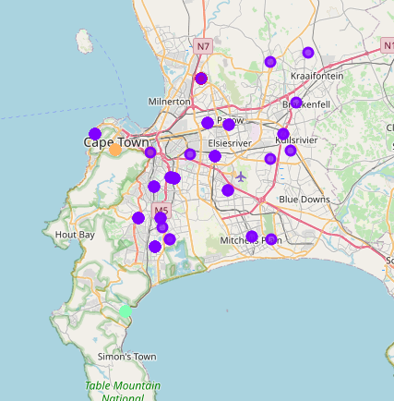

1.Purple circle – Urban friendly (Cluster 2)

2.Orange circle – Countryside

3.Green circle – Beach and party

**Cluster 2**

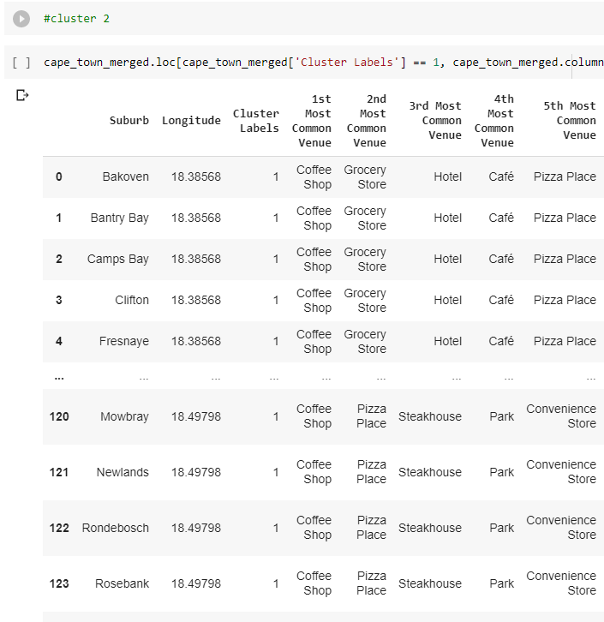

**Cluster 4**

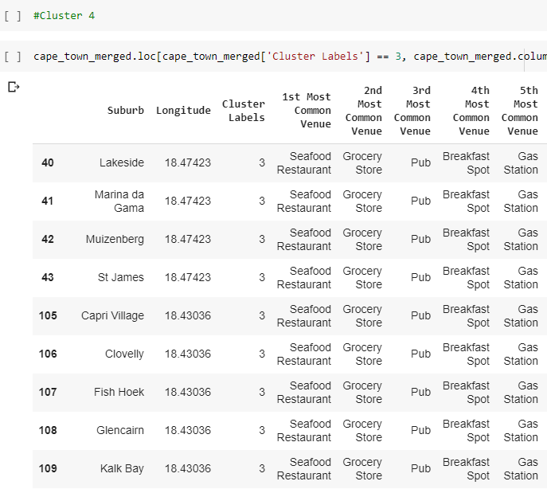

**Cluster 5**

